**Assignment-12-May-2022:**

1. **What is lifecycle rule? Write the steps with screen shots.(Any one like transition from one class to other)**

An S3 Lifecycle configuration is a set of rules that define actions that Amazon S3 applies to a group of objects. There are two types of actions.

**Transition actions** – These actions define when objects transition to another storage class. For example, you might choose to transition objects to the S3 Standard-IA storage class 30 days after creating them, or archive objects to the S3 Glacier Flexible Retrieval storage class one year after creating them.

**Expiration actions** – These actions define when objects expire. Amazon S3 deletes expired objects on your behalf.

Go to one of the created bucket (renatis3bucket). Go to management. Choose Create life cycle rule and click on it.

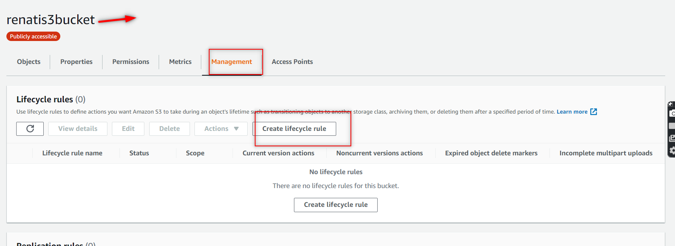

Provide the name ,and choose apply to all objects in the bucket and in select move current versions of objects btw storage classes.

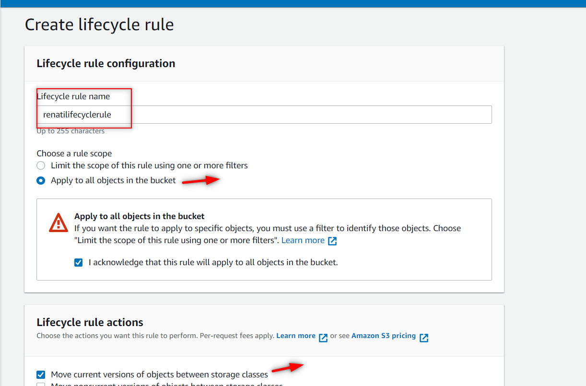

Here choose the storage classes which u want and select days as well.and then click on create .

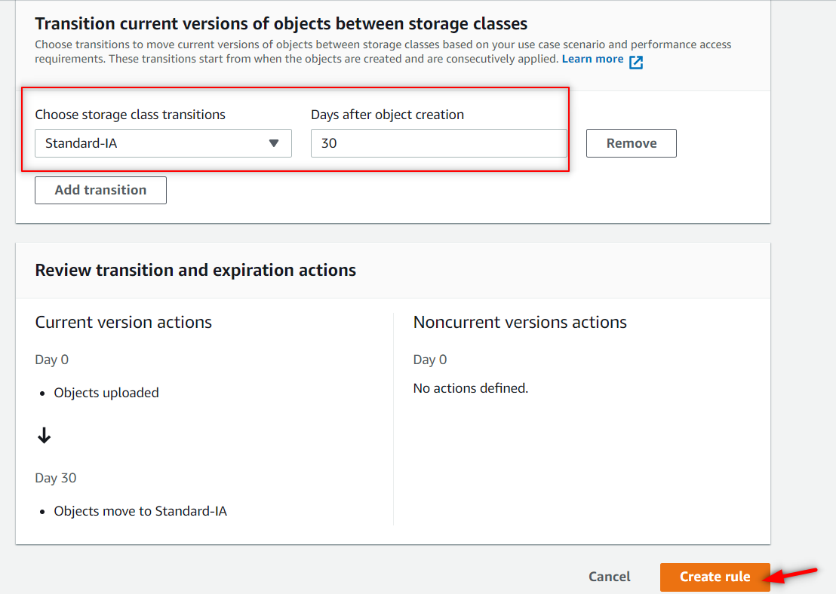

1. **What is S3 Object lock?**

With S3 Object Lock, you can store objects using a write-once-read-many (WORM) model. Object Lock can help prevent objects from being deleted or overwritten for a fixed amount of time or indefinitely. You can use Object Lock to help meet regulatory requirements that require WORM storage, or to simply add another layer of protection against object changes and deletion.

1. **What is S3 Glacier Vault Lock?**

S3 Glacier Vault Lock **allows you to easily deploy and enforce compliance controls for individual S3 Glacier vaults with a vault lock policy**. You can specify controls such as “write once read many” (WORM) in a vault lock policy and lock the policy from future edits. Once locked, the policy can no longer be changed.

1. **What is SRR? Explain with Hands on steps**

Same-Region Replication (SRR) is **used to copy objects across Amazon S3 buckets in the same AWS Region**. SRR can help you do the following: Aggregate logs into a single bucket – If you store logs in multiple buckets or across multiple accounts, you can easily replicate logs into a single, in-Region bucket.

Create 2 buckets with same region. Now go to management and click on create on create replication rule.

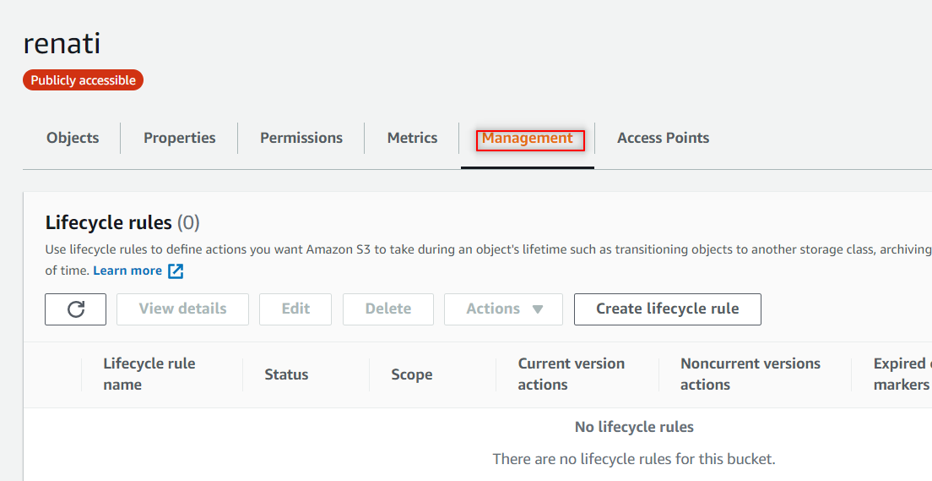

**Provide all the necessary data and make sure that the versioning is enabled and proper destination as well. Here the created replication rule shown as below**

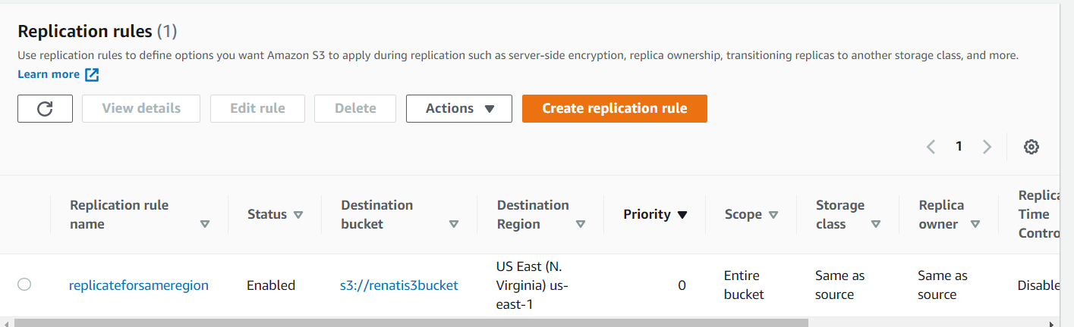

**Add one file where u created the replication and see that file got replicated to another bucket as shown in below.**

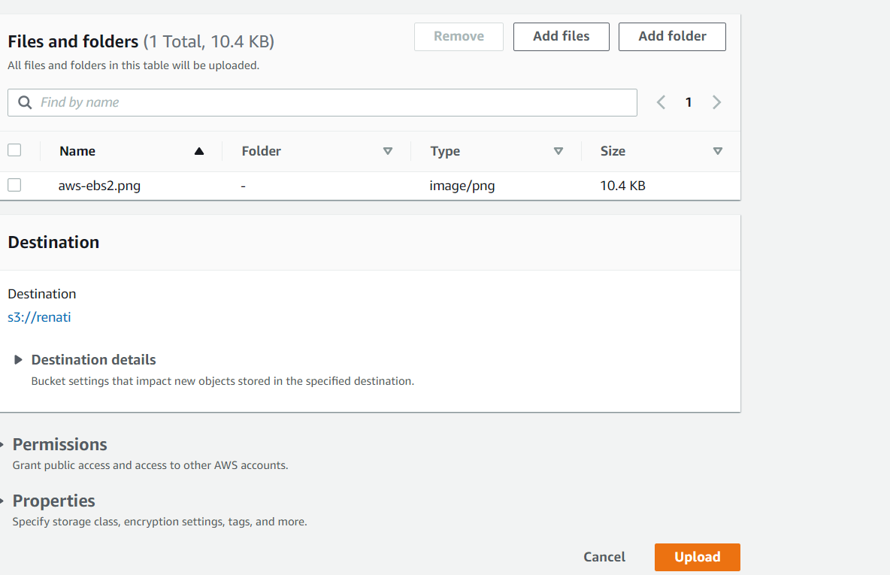

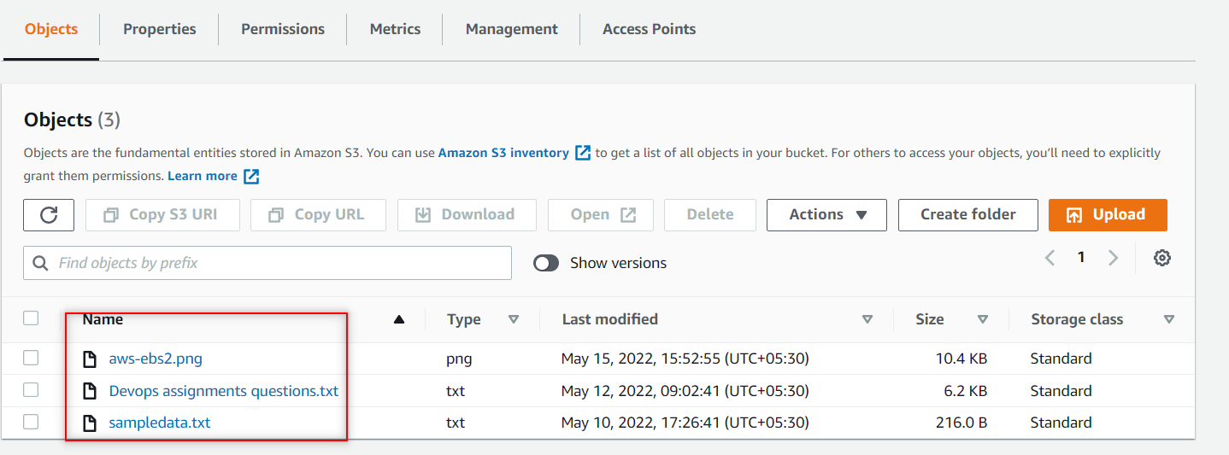

1. **What CRR?**

* Cross Region Replication is a feature that replicates the data from one bucket to another bucket which could be in a different region.
* It provides asynchronous copying of objects across buckets. Suppose X is a source bucket and Y is a destination bucket. If X wants to copy its objects to Y bucket, then the objects are not copied immediately.

Create two buckets in different regions as shown in below.

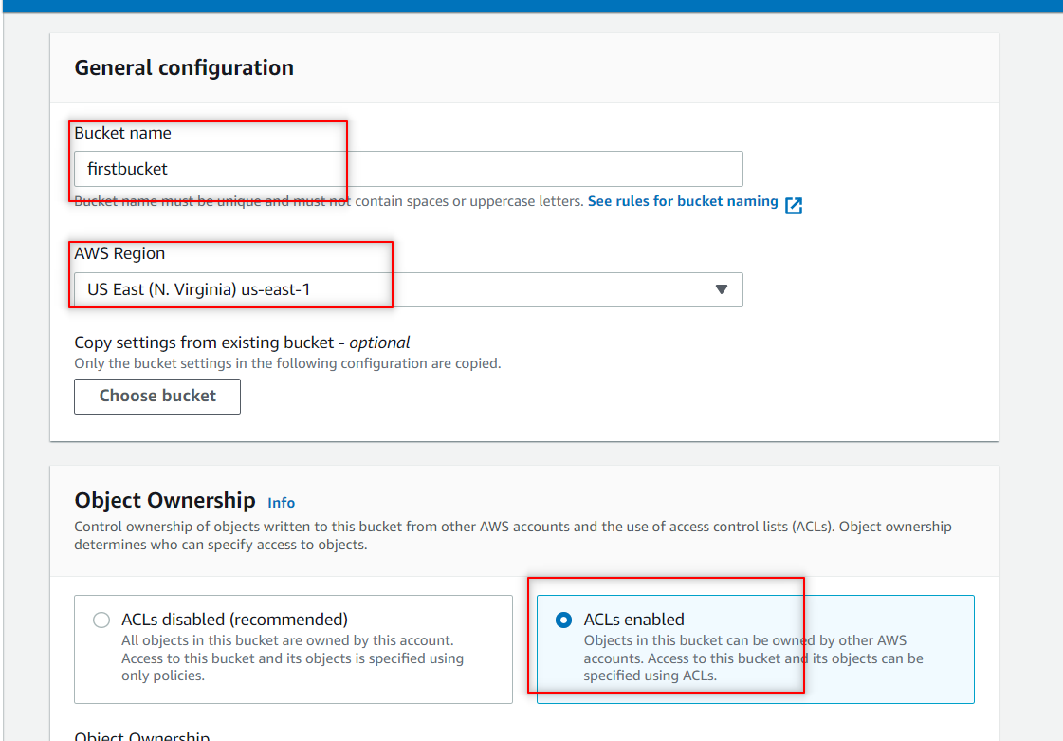

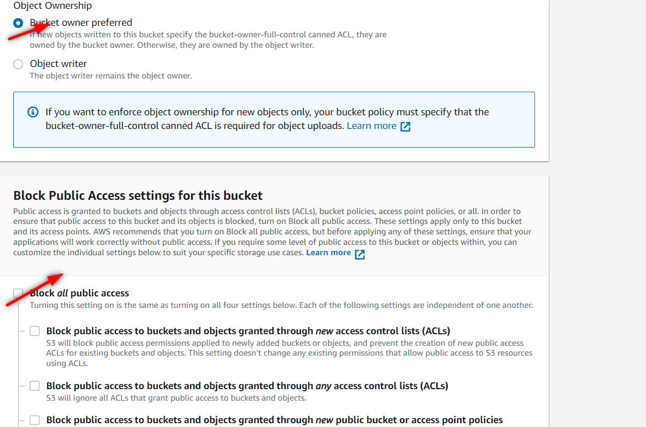

**For second bucket chose the different AWS region .**

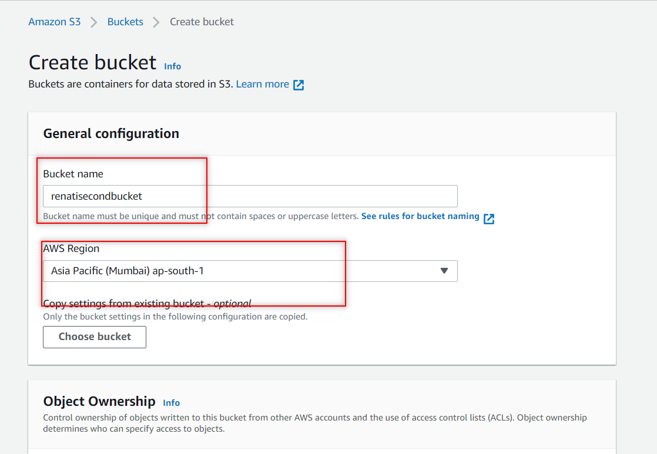

**Here the 2 buckets are created.**

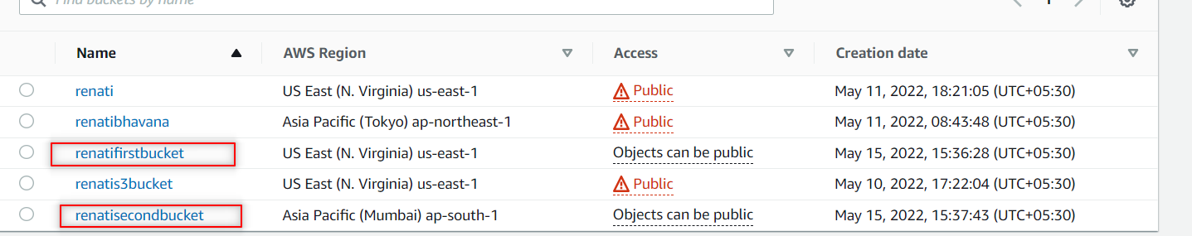

**To make them both public click on permissions. And click on ACL edit button and check the boxes and click on save changes.**

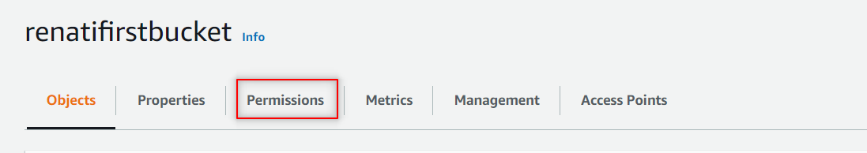

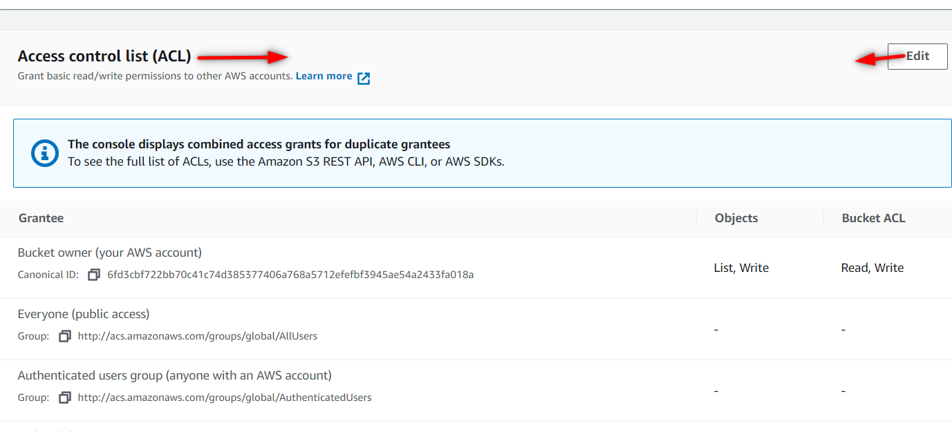

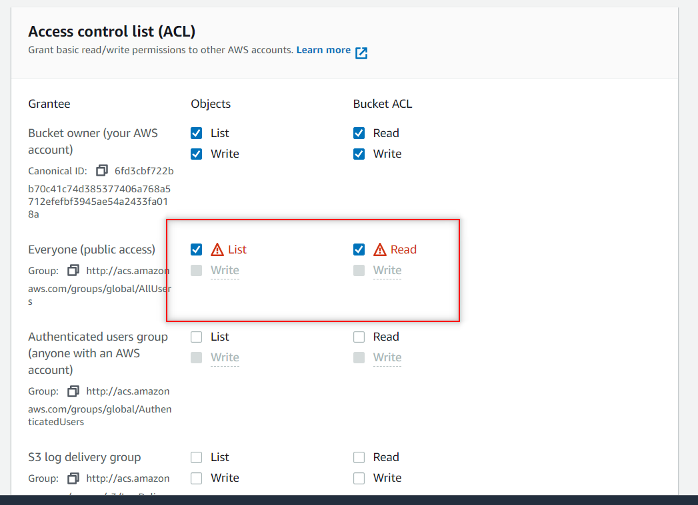

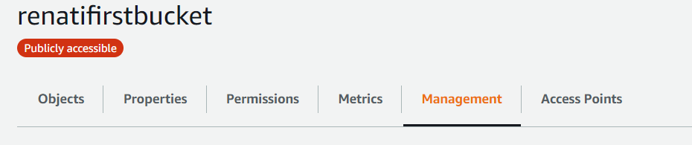

**Now go to Management under first bucket and click on create replication rule.**

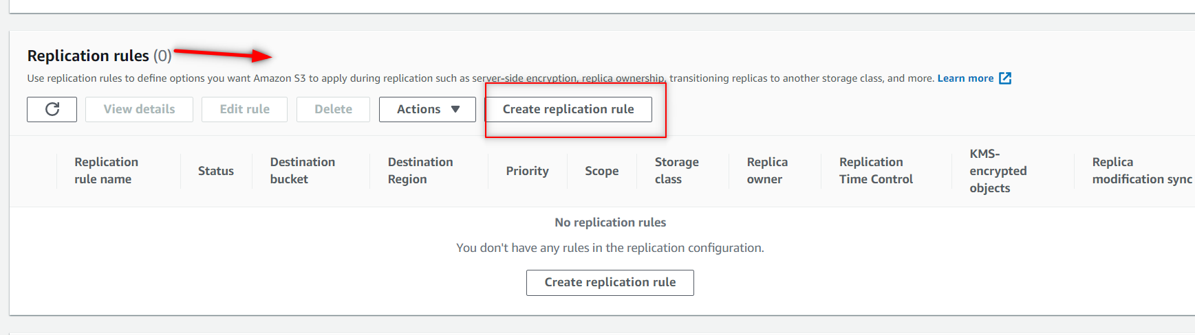

**Provide the replication name and status as enabled.**

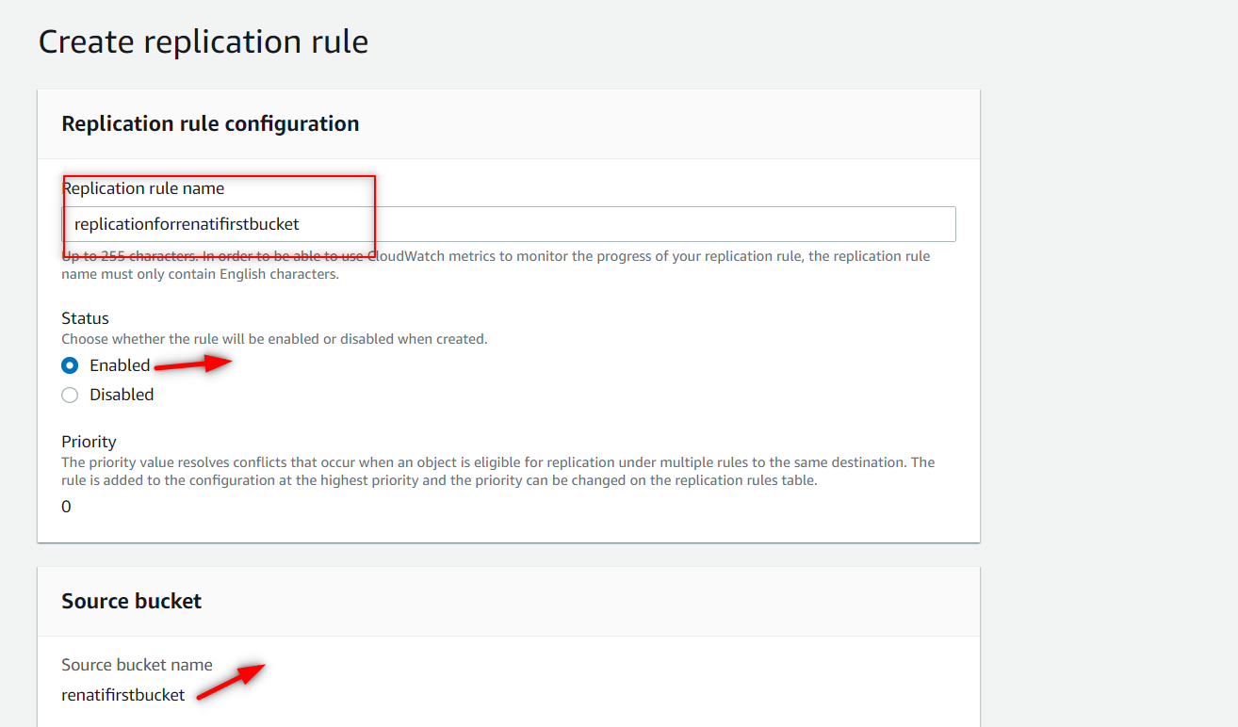

**Here choose the Apply to all objects in the bucket option. And in destination choose the choose a bucket in this account. And browse the bucket name to where u want to replicate the objects.**

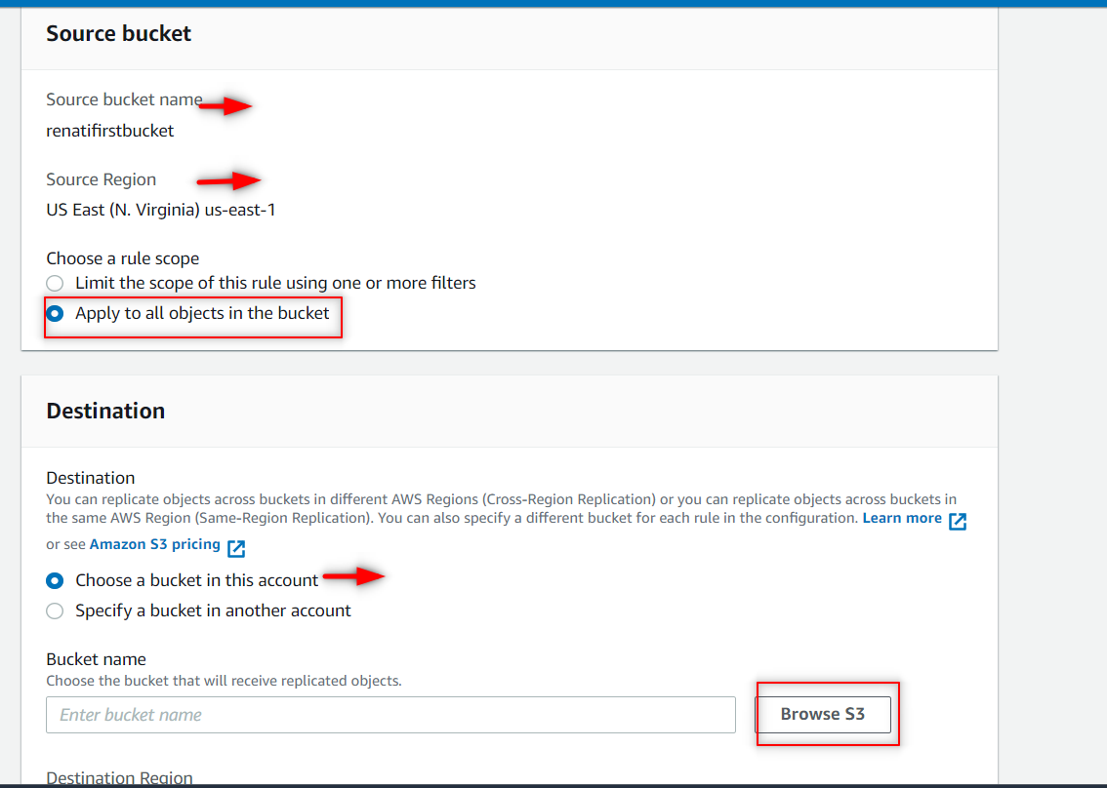

**Choosethe past of second bucket**

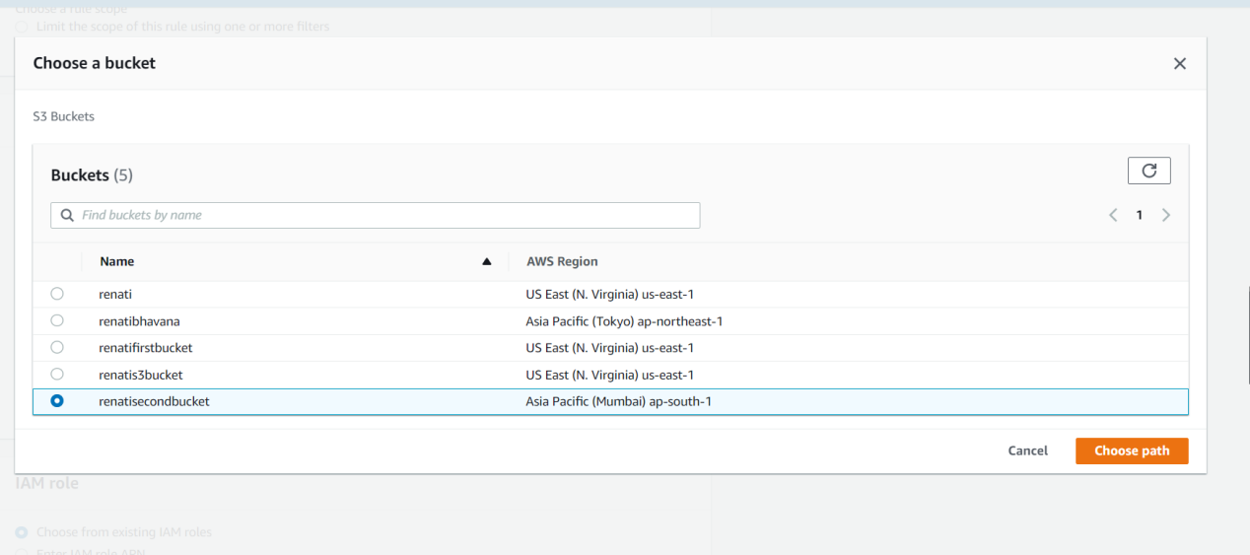

**Under IAM role choose the option Create new role. And click on save**

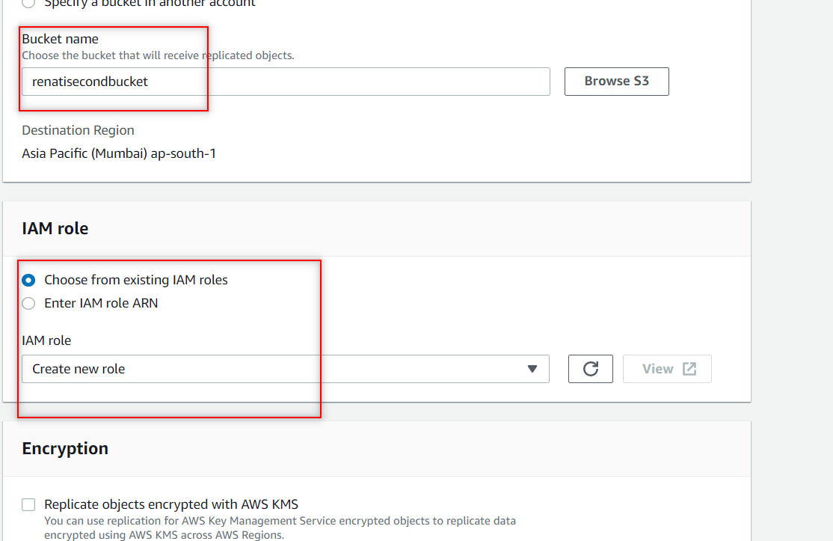

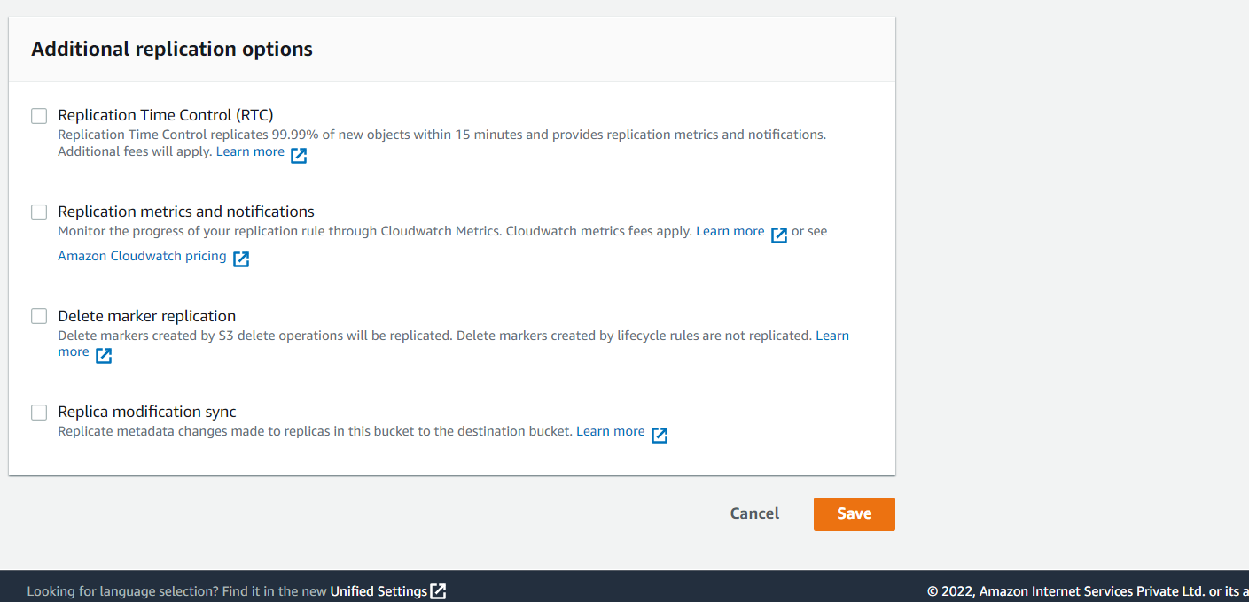

**Here , choose No, do not replicate existing objects and click on submit.**

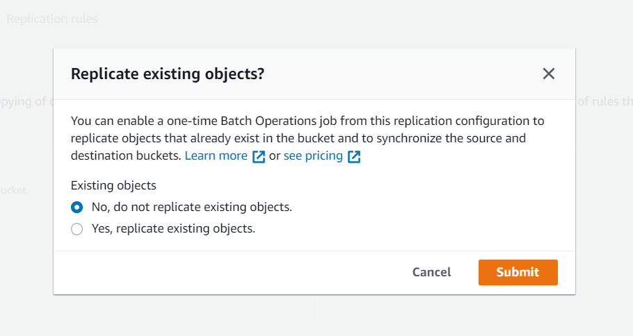

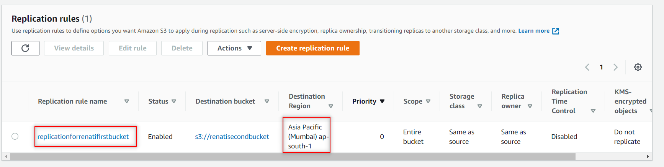

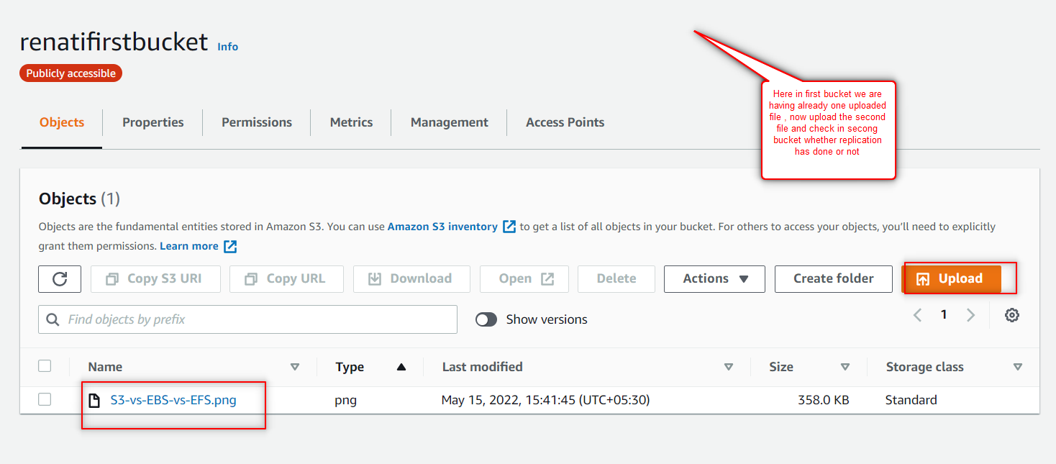

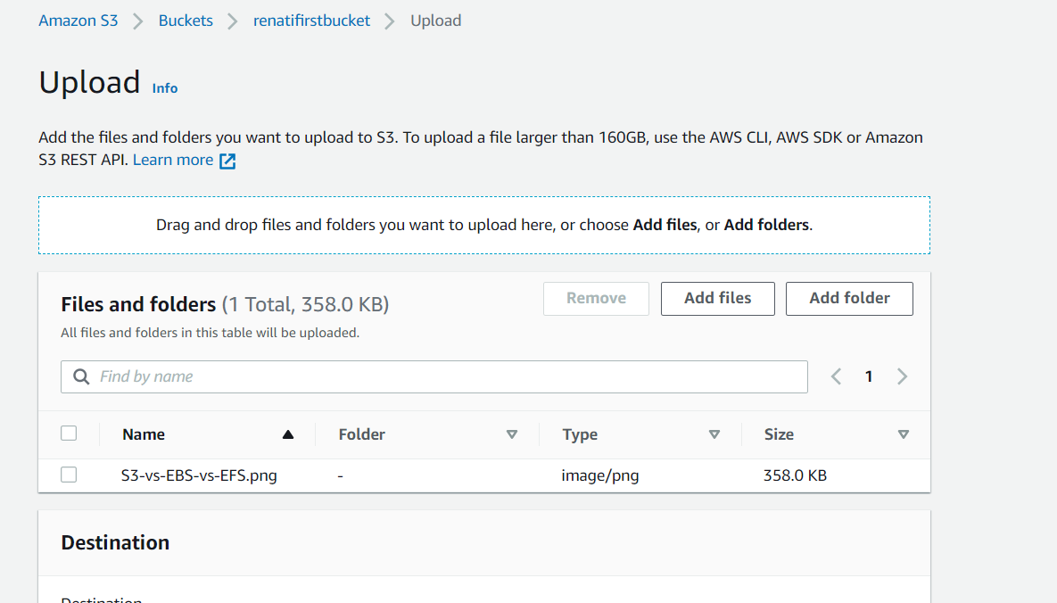

**Add one file in the first bucket and check in second bucket whether the file got replicated or not.**

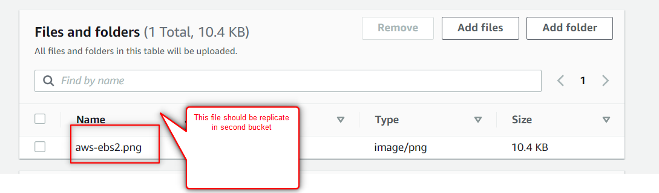

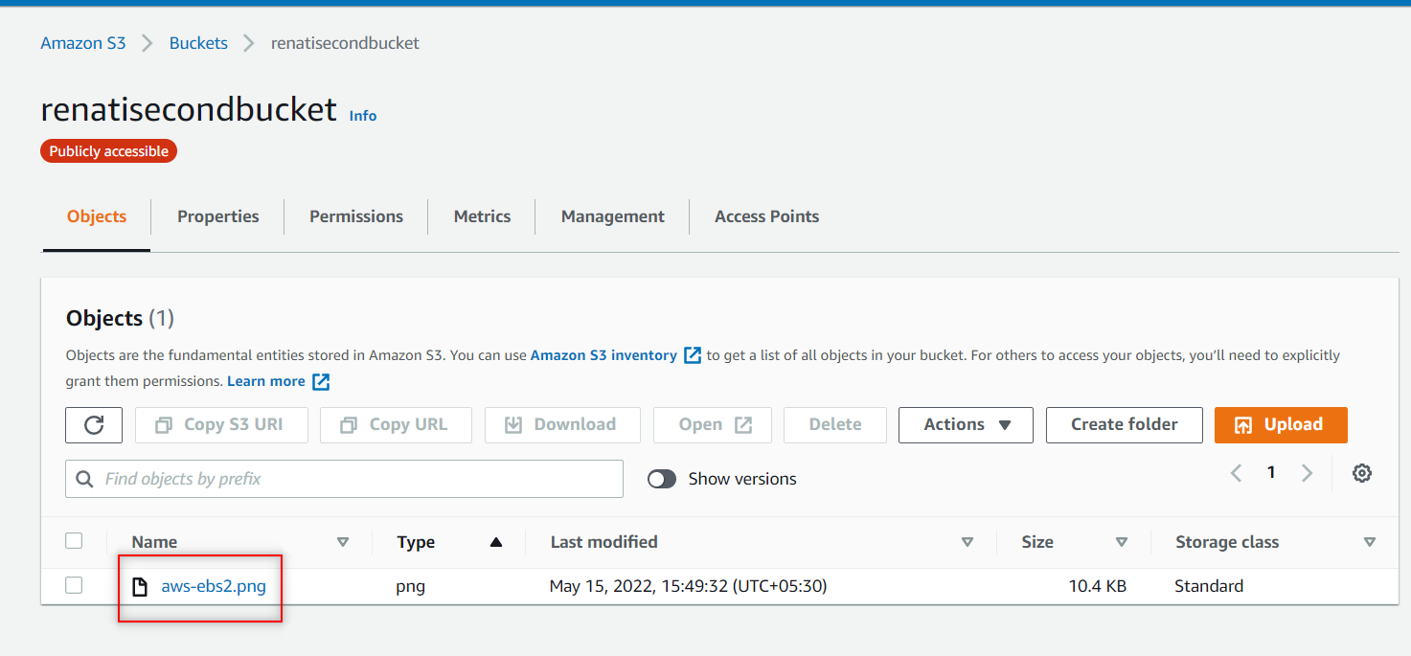

1. **How to enable versioning – Hands on steps**

**While creating a bucket it self you can enable the versioning.**

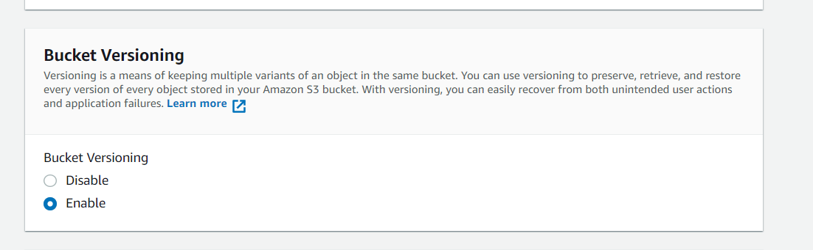

**If u already created a bucket after that u want to enable the bucket versioning follow these steps:**

**Go to u r bucket , click on properties and under Bucket Versioning click on edit option.**

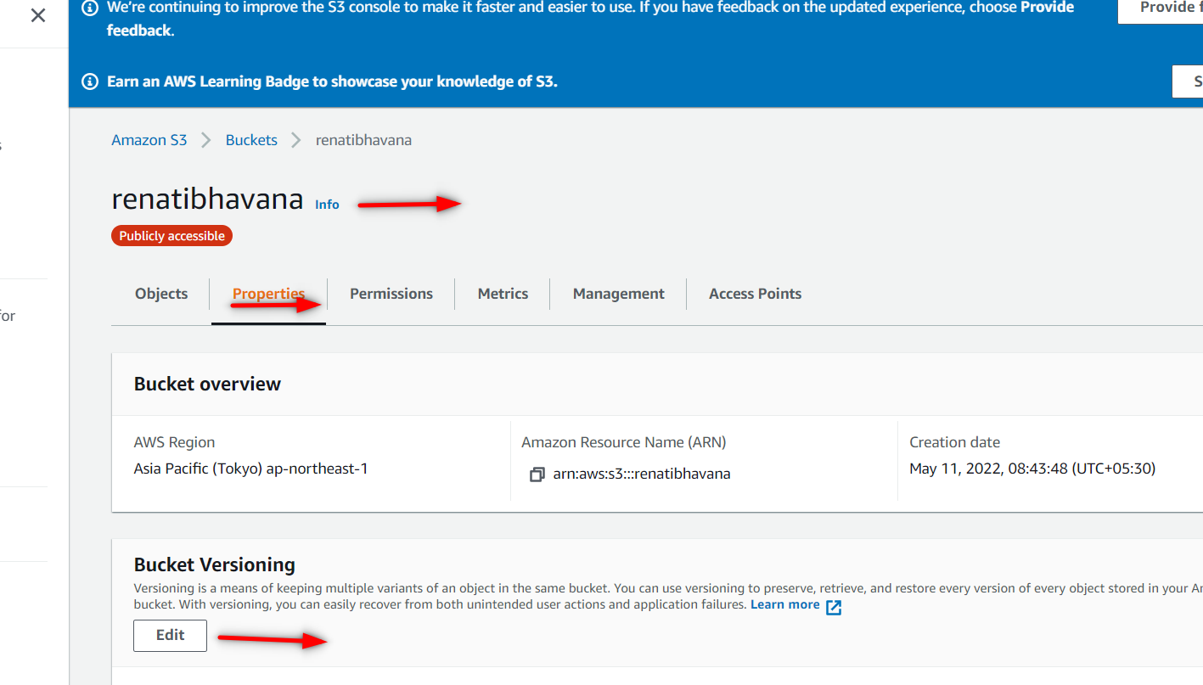

**Here select the Enable option and click on save button.**

